Learn, Practice, master loop

Kinds of motivation. Extrinsic and Intrinsic (Positive and negative for each)

* Positive intrinsic motivation because the player will want to hit the other player
* Positive extrinsic motivation because when you finally hit the player, you will be rewarded by winning the game or having an advantage because you now know the position and power to hit your opponent.
* Negative extrinsic motivation because if you fail to hit your opponent, it’s now his go and he knows exactly where you are and how much power. Because you didn’t make the shot, you’re now in a position to lose.

To encourage the player to keep playing this game we need to refer to the **Mihaly Csikszentmihalyi Flow.**

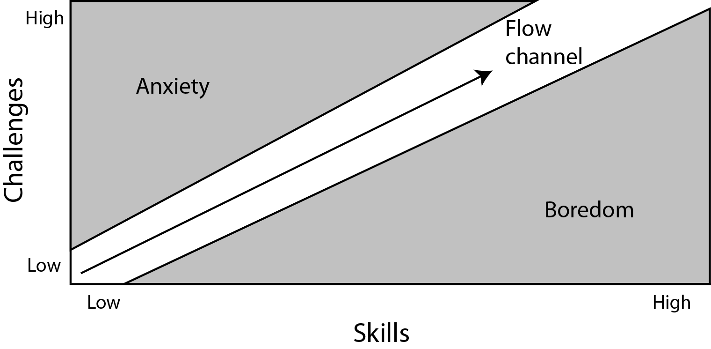

This Graph shows that there’s a correlation between the skill of the player, the challenges in a game and how much fun you’re having. We don’t want to make the game super easy because the player will just get bored but at the same time we don’t want it to be too difficult because the player will just give up and yet again put it down. To make sure we stay in the flow channel we will keep referring to the “learn, practice, master loop”.

Nicole Lazzaro – Four keys to fun - <https://www.youtube.com/watch?v=EEmNRRRqgNc>

<http://www.nicolelazzaro.com/the4-keys-to-fun/>

as a group we aim to hit hard fun (Fiero) and people fun.

Because this is a turn base game and you’re competing against each other, you’re naturally going to have people fun as you’re with your friends. We will need to implement a bit of hard fun because if not the player will get bored, this type of game requires a bit of skill or at least trial and error. If we stayed with simple pleasures for our type of game then when player 1 taps the screen, his opponent will lose health. That wouldn’t be fun. The player will have to use different skills to hit their opponent. This skills will be basic though, timing, understanding powers and the angle.

An idea to force this “learn, practice, master loop” idea into our game, we could start off with level 1, a player having to hit their opponent which is 10m away, on a flat surface and there’s no obstacles. Level 2 however is you have to hit your opponent 20m away and there’s a moving obstacle between the both of you going up and down. Level 3, you’re now 30m away, there’s a moving obstacle in your way again and now moth players are on a moving platform going left and right. 1st level required the player to get the angle and power correct to hit their opponent. The 2nd level required the player to get the angle, power and basic timing correct to hit their opponent. The 3rd level required the player to get the angle, power and more advanced timing correct to hit their opponent.